
Sponsorship Form
Please complete the information below and return these forms to the school by October 12, 2012.
Sponsor’s Name (First and Last): _______________________________________________________
Business Name (if applicable): _______________________________________________________
Address: __________________________________________________________________________
Phone Number: ____________________________ Email: _______________________________

Please place your signature in the appropriate box below indicating your level of sponsorship. Once again, thank you for your generosity!

Jaguar Level $1,000 and Over
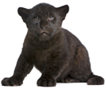
Please circle the appropriate choices below:
- Wristbands for festival or 35 Raffle tickets
- Free vendor booth or Free half page ad in Yearbook
You are also eligible to receive 2 complimentary shirts. Please indicate 2 sizes and quantities:
YS____ YM____ YL____ S____ M____ L____ XL____
You will also receive 2 adult and 2 child dinner plates. Please complete the attached form for your order.

Signature: ____________________________________

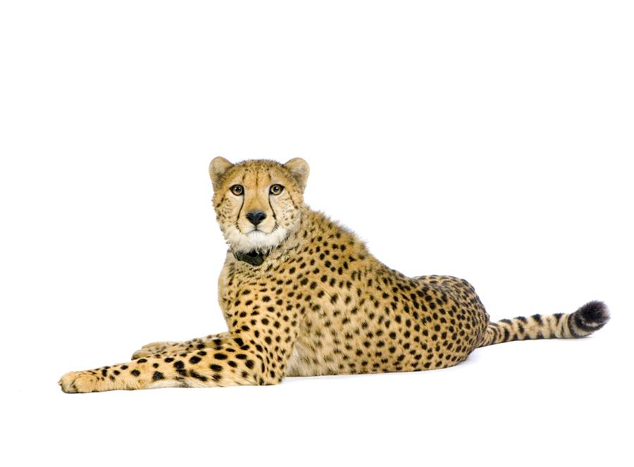
Cheetah Level $500
Please circle the appropriate choices below:
- Wristbands for festival or 25 Raffle tickets

You are also eligible to receive 1 complimentary shirt. Please indicate the size:
YS____ YM____ YL____ S____ M____ L____ XL____
You will also receive 2 adult dinner plates. Please complete the attached form for your order.

Signature: ____________________________________


Tiger Level $200
Please circle the appropriate choices below:
- Wristbands for festival or 15 Raffle tickets
You will also receive 2 child dinner plates. Please complete the attached form for your order.

Signature: ____________________________________

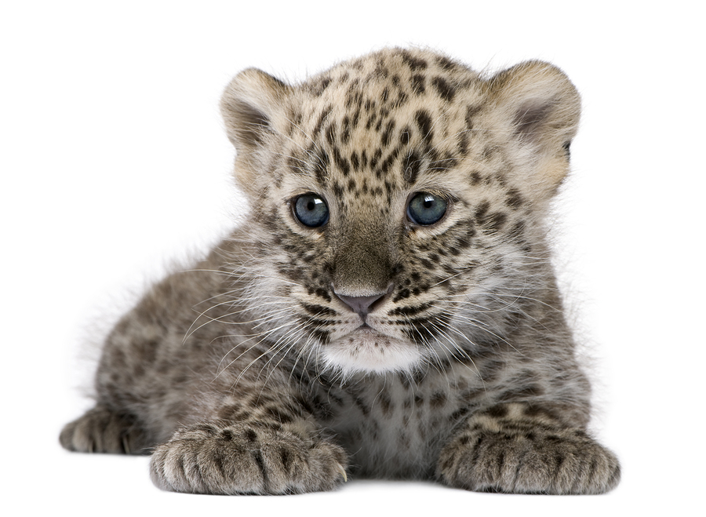
Leopard Level $150
Please circle the appropriate choices below:
- Wristbands for festival or 10 Raffle tickets

Signature: ____________________________________

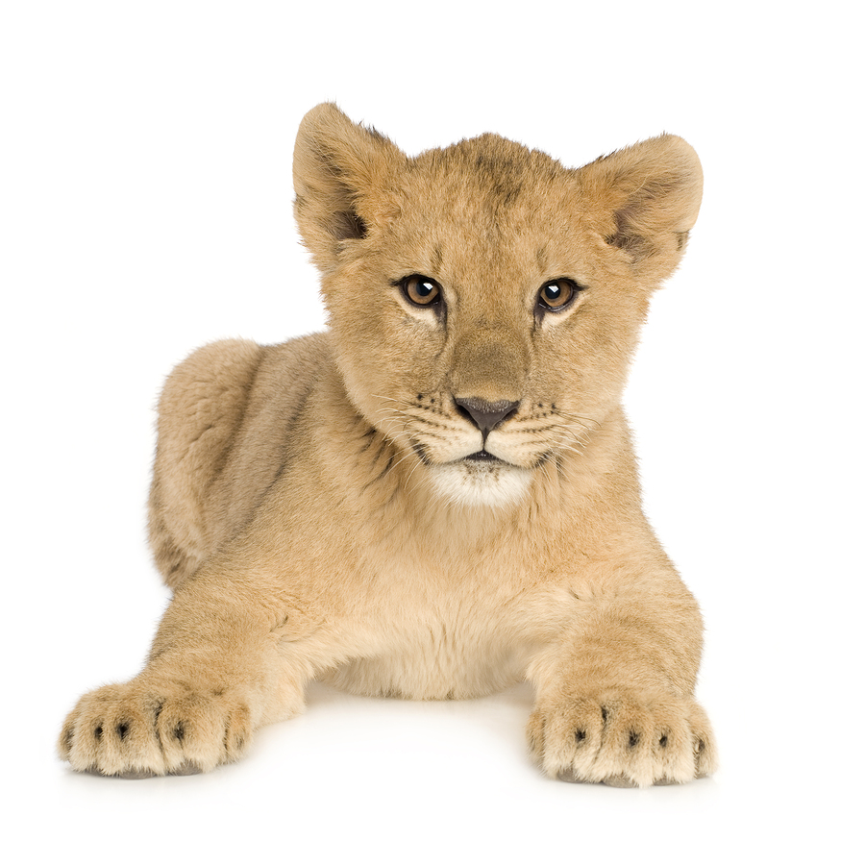
Lion Level $75
Please circle the appropriate choices below:
- Wristbands for festival or 10 Raffle tickets

Signature: ____________________________________


Vendor Booth (please circle one)
- Sales Vendor Booth $100
- Marketing Vendor Booth $50

Signature: ____________________________________

Please make checks payable to The New School Montessori Center.
The New School Montessori Center
5617 Sunset Lake Road
Holly Springs, NC 27540

All contributions support the New School Montessori Center educational activities and facilities. Contributions are tax-deductible to the extent allowed by the law.

