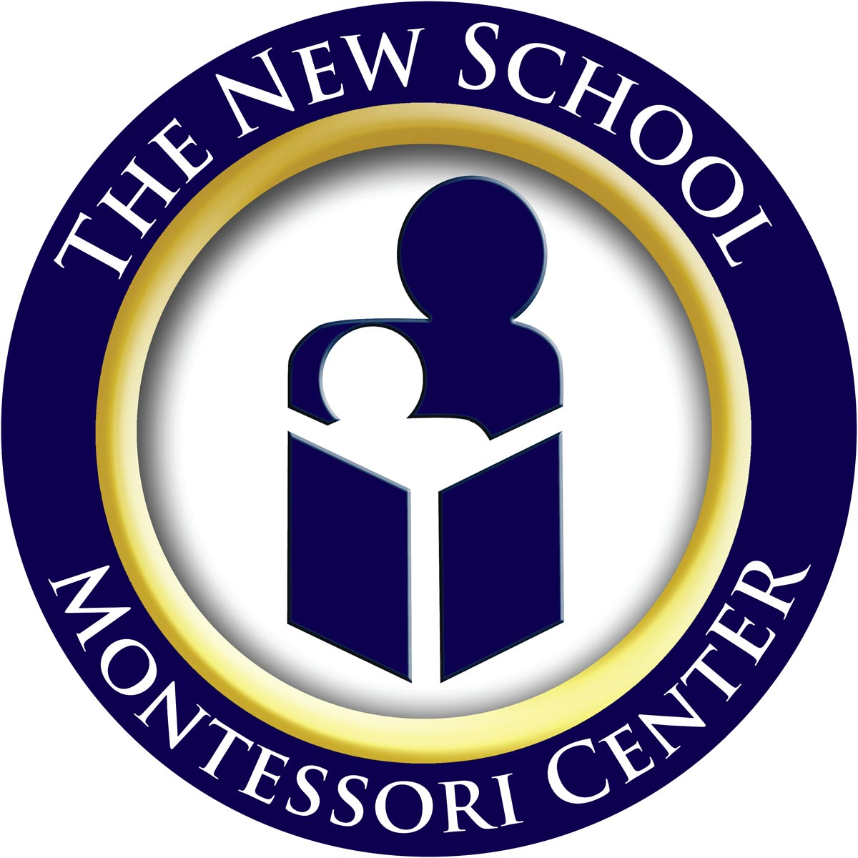
The New School, Inc.
A Montessori Center for Children

SUMMER 2011 INFORMATION
The New School’s summer program is available to children currently enrolled or who are planning to enroll in the fall of 2011. The summer program runs for a period of 10 weeks. Unlike the regular school year, enrollment is offered on a weekly basis. However, we do strongly encourage your child’s attendance to be consistent and on consecutive weeks if possible.

Summer is an important time for our faculty to relax, refresh their materials and training, and plan for the upcoming year. As such, your child may have a different teacher or caregiver depending on the week your child attends. The Montessori lessons and projects offered, however, will be pre-planned in order to provide consistency within our program. To counterbalance the changes inherent to a summer program, we provide fun activities such as water day, extra art, drama, and music activities, etc.

We also make every effort to ensure as much consistency as possible in terms of class composition. To help us with this, we have created the following structure for enrollment:

- If you sign up for 5 days per week, there is a 4-week minimum.
- If you sign up for 3 or 4 days per week, there is a 6-week minimum.
- If you sign up for 2 days, you must sign up for all 10 weeks of the program.

There are limited spaces available and enrollment will end when the classes are full. Admission into the summer program will be on a first come, first serve basis. Applications received after the classes have been filled will be returned to the parents with any paid fees.

If you are interested in enrolling in the summer program, please return the enclosed application form by Monday, April 25^{th.} The summer tuition is divided into three equal payments. The first payment of the summer tuition must be paid in advance and is a non-refundable payment. The second payment is due June 28th, and the final summer payment is due July 28th.

This year we are considering the possibility of running a summer program for elementary students. This will be based on interest and availability of teachers. Elementary students need to attend 5 days per week with a minimum of 4 weeks. Please let us know if you have a child enrolled in our program that would be interested in attending during the summer. In order to arrange this program we need this feedback very quickly. Please indicate on the attached form if you are interested in this program.

Please note that every summer we share our building with the Center for Montessori Teacher Education. You may see unfamiliar adults in the building training for their Montessori certification. Please note that our security procedures may be modified during the time these teachers are present. We will advise you of any changes as needed.

Please let us know if you have any questions.

New School Montessori Center Administration

5617 Sunset Lake Road, Holly Springs, NC 27540
Tel: 919-303-3636 • Fax: 919-303-3605 • www.montessoricenter.org • info@montessoricenter.org

Tuition Rates for Five-Day Week Schedules

Program | Times | Price
Half Day Infants | 8:30am – 12:00pm | $185/week
Full Day Infants | 8:30am – 4:30pm | $305/week
Half Day Toddler Ones | 8:30am – 12:00pm | $180/week
Full Day Toddler Ones | 8:30am – 4:30pm | $295/week
Half Day Toddler Twos | 8:30am – 12:00pm | $173/week
Full Day Toddler Twos | 8:30am – 4:30pm | $280/week
Half Day Children’s House | 8:30am – 12:00pm | $150/week
Full Day Children’s House | 8:30am – 4:30pm | $248/week
Elementary | 8:30am – 3:30pm | $230/week

Tuition Rates for Split-Week Schedules
Infants
Two-Day Schedule | Three-Day Schedule | Four-Day Schedule
Half Day  $74/week | Half Day  $111/week | Half Day  $148/week
Full Day  $122/week | Full Day  $183/week | Full Day  $244/week

Toddler Ones
Two-Day Schedule | Three-Day Schedule | Four-Day Schedule
Half Day  $72/week | Half Day  $108/week | Half Day  $144/week
Full Day  $118/week | Full Day  $177/week | Full Day  $236/week

Toddler Twos
Two-Day Schedule | Three-Day Schedule | Four-Day Schedule
Half Day  $69.20/week | Half Day  $103.80/week | Half Day  $138.40/week
Full Day  $112/week | Full Day  $168/week | Full Day  $224/week

Children’s House
Two-Day Schedule | Three-Day Schedule | Four-Day Schedule
Half Day  $60/week | Half Day  $90/week | Half Day  $120/week
Full Day  $99.20/week | Full Day  $148.80/week | Full Day  $198.40/week

The New School, Inc.
A Montessori Center for Children

SUMMER 2011 APPLICATION

Child’s Name _________________________________________________________________________________________

Date of Birth ____________________________________________ Child’s Age as of 6/6/11 ________________

Current Teacher (if already attending) ____________________________________________________________
Please indicate your requested days per week:
Top of Form
<INPUT TYPE=\ 5 days per week
<INPUT TYPE=\ 4 days per week (please select which days: M T W Th F )
<INPUT TYPE=\ 3 days per week (Wed, Thurs, Fri)
<INPUT TYPE=\ 2 days per week (Mon, Tues)
(If the schedules above do not work for you, please contact the office as soon as possible to discuss the possibility of other options.)
Bottom of Form

Please indicate your requested weeks:

<INPUT TYPE=\ I would like my child to attend all 10 weeks of the summer program
<INPUT TYPE=\ I would like my child to attend the following weeks:
 | Week 1 (June 6 – 10) |  | Week 6 (July 11 – 15)
 | Week 2 (June 13 – 17) |  | Week 7 (July 18 – 22)
 | Week 3 (June 20 – 24) |  | Week 8 (July 25 – 29)
 | Week 4 (June 27 – July 1) |  | Week 9 (Aug 1 – 5)
 | Week 5 (July 5 – 8)** |  | Week 10 (Aug 8 – 12)
**Important Note: If you are attending during the July 4th week, please note that this week will be prorated at 80% of whatever the normal weekly rate is due to our shortened week.
Please indicate your requested program:
<INPUT TYPE=\ Infant / Toddler Ones <INPUT TYPE=\ Children’s House
<INPUT TYPE=\ Toddler Twos <INPUT TYPE=\ Elementary (subject to availability)
Please indicate your requested schedule:
<INPUT TYPE=\ Half Day (8:30am to 12:00pm) <INPUT TYPE=\ Full Day (8:30am to 4:30pm)
<INPUT TYPE=\ Elementary (8:30am to 3:30pm)

Please indicate whether or not you may need before or after-school care:
<INPUT TYPE=\ I may need before-school care <INPUT TYPE=\ I may need after-school care
<INPUT TYPE=\ I will definitely not need either before or after-school care
Please note that before-school care in the summer begins at 7:30am and after-school care ends at 5:30pm.

Child Care Rates
Program | Hours | Price
Before & After Class Hours for  Infants and Toddler Ones | 7:30am – 8:20am  4:30pm – 5:30pm | $7.50/hour
Before & After Class Hours for  Toddler Twos, Children’s House & Elementary | 7:30am – 8:20am  4:30pm – 5:30pm | $5.10/hour
Extended Class Hours for  Infants and Toddler Ones | 12:00pm – 4:30pm | $9.35/hour
Extended Class Hours for  Toddler Twos, Children’s House & Elementary | 12:00pm – 4:30pm | $7.50/hour

Please check one of the following:
<INPUT TYPE=\ I have signed up for 2 days and agree to pay for 10 weeks
<INPUT TYPE=\ I have signed up for 3 or 4 days and agree to pay for a minimum of 6 weeks
<INPUT TYPE=\ I have signed up for 5 days and agree to pay for a minimum of 4 weeks

Tuition Payments
By signing below, you are indicating that you are enrolling your child in our 2011 summer program and that you agree to adhere to all regulations and guidelines as described in our Parent Handbook.

By signing below you are also acknowledging the following:

The total payment for the summer program I selected will be: ________________________

I agree to pay for this program in three equal payments of: ____________________________

I have attached the first of the three payments with this application form.

I agree to pay the second payment by June 28th and the third payment by July 28th.

________________________________________________________
Parent Signature

________________________________________________________
Parent Signature

